# This demo will create 2 schema called Internet and Instore

1. Step1: Right click on **Schemas** in **Security** of Fsoft_Training database and choose **New Schema...**

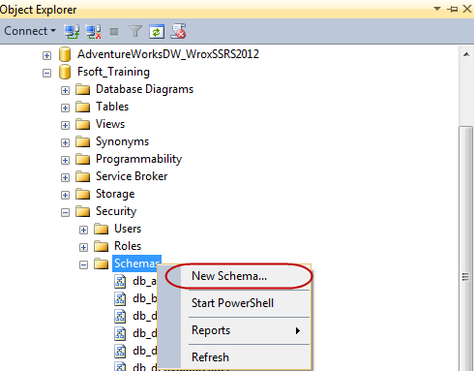

1. In **Schema** dialog enter Internet in **Schema** name textbox and click **OK**

